**What is Tetris?**

It is really simple game to play. A possibility of twelve different shaped blocks will fall down from the top of the screen, one at a time. The object of the game is to keep the blocks from stacking up all the way to the top of the screen. To avoid the blocks from stacking all the way to the top, you need to completely fill a horizontal line. Doing so will cause the line to disappear and give you points. To form these horizontal lines, you can move the blocks left or right, as well as rotate them.

**Controls**

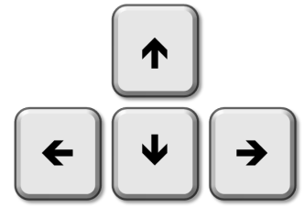

The controls during gameplay use the arrow keys from the keyboard.

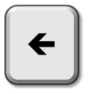

The left arrow will move the block to the left

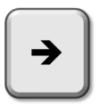

The right arrow will move the block to the right

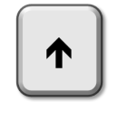

The up arrow will rotate the shape



The down arrow will make the shape move faster down the screen

**Getting Started**

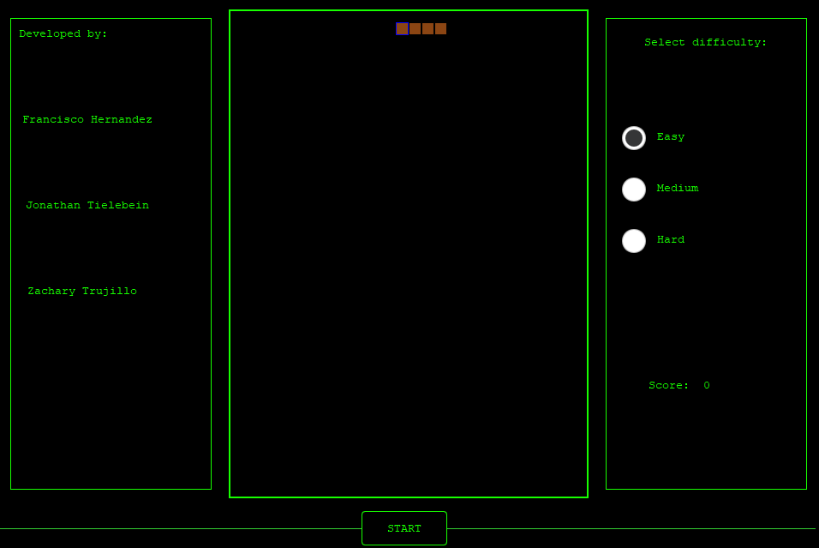To start playing, on the right-hand side, you need to select which level of difficulty you would like: Easy, Medium or Hard and then on the bottom of the screen, press START. As the choice of level of difficulty increases, the speed at which the blocks drop will increase; as well as more difficult shapes will be dropped.

**How To Play?**

A possibility of twelve blocks will start to drop down from the top of the screen.



Once they start dropping, you can press the left-arrow key to move the shape to the left, the right-arrow key to move the shape to the right, the up-arrow key to rotate the shape, or the down-arrow key to make the shape move faster to the bottom. You can also pause the game at any time by pressing the Pause button at the bottom of the screen; once you are ready to begin play again, press Start.



Rotate and move the shapes into position so that you create a full line across the screen.

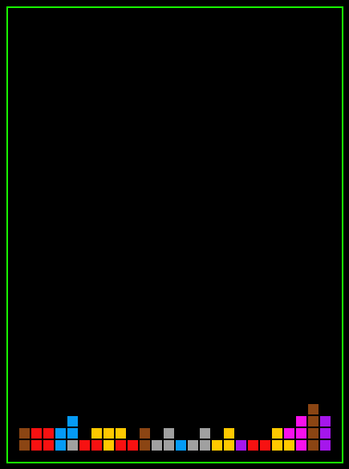

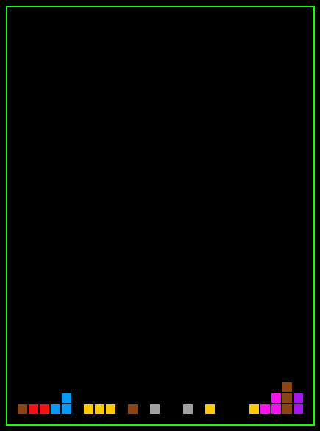Doing so, will cause the line to disappear and your score will increase.

Keep clearing lines to increase your score and to prevent the shapes from piling up to the top of the screen. Once the shapes reach the top of the screen then your game will be over.

